**Comprehensive Guide to Amazon EC2**

**Introduction to Amazon EC2**

Amazon Elastic Compute Cloud (Amazon EC2) is a web service offered by Amazon Web Services (AWS) that provides resizable compute capacity in the cloud. EC2 allows users to launch and manage virtual servers, known as instances, which can host applications, run software, or handle workloads without the need for physical hardware.

**Why Use Amazon EC2?**

**1. Scalability**

* Easily scale instances up or down based on workload requirements.
* Use Auto Scaling to automatically maintain application availability and adjust capacity as needed.

**2. Cost-Effectiveness**

* Pay only for the compute time you use.
* Choose from various pricing models:
  + **On-Demand Instances:** Pay per hour or second with no long-term commitment.
  + **Reserved Instances:** Save up to 75% by committing to a 1- or 3-year term.
  + **Spot Instances:** Bid for unused capacity to save costs, ideal for flexible, non-critical workloads.

**3. Flexibility**

* Wide variety of instance types to suit diverse use cases (e.g., general-purpose, compute-optimized, memory-optimized).
* Run operating systems such as Linux, Windows, or custom AMIs.

**4. Reliability**

* Built on AWS’s highly reliable infrastructure with data centers across the globe.
* Enable high availability by deploying instances across multiple Availability Zones.

**5. Security**

* Leverage robust security features like:
  + Amazon Virtual Private Cloud (VPC) for isolated networking.
  + Identity and Access Management (IAM) for user permissions.
  + Encryption of data at rest and in transit.

**Types of EC2 Instances**

Amazon EC2 offers various instance types designed to cater to different workloads and use cases:

**1. General Purpose Instances**

* **Examples:** t3, t4g, m5, m6g
* Balanced performance for compute, memory, and networking.
* Suitable for web servers, development environments, and small databases.

**2. Compute-Optimized Instances**

* **Examples:** c5, c6g, c7g
* High-performance CPUs for compute-intensive tasks.
* Ideal for batch processing, gaming servers, and high-performance computing.

**3. Memory-Optimized Instances**

* **Examples:** r5, r6g, x2idn, u-12tb1.metal
* Optimized for applications requiring high memory.
* Suitable for big data analytics, in-memory databases, and real-time processing.

**4. Storage-Optimized Instances**

* **Examples:** i3, i4i, d2, h1
* High, sequential read/write access to large datasets.
* Ideal for NoSQL databases, file systems, and data warehousing.

**5. Accelerated Computing Instances**

* **Examples:** p4, g4ad, inf1
* GPUs and FPGAs for intensive computing tasks.
* Suitable for machine learning, AI, and 3D rendering.

**6. Bare Metal Instances**

* Provides direct access to the physical hardware.
* Suitable for specialized workloads requiring low-level hardware features.

**How to Use Amazon EC2**

**Step 1: Plan Your Use Case**

Identify your requirements, such as:

* Instance type (e.g., compute-optimized, memory-optimized).
* Expected traffic and workload.
* Data storage needs.

**Step 2: Access the AWS Management Console**

* Log in to your AWS account and navigate to the EC2 Dashboard.

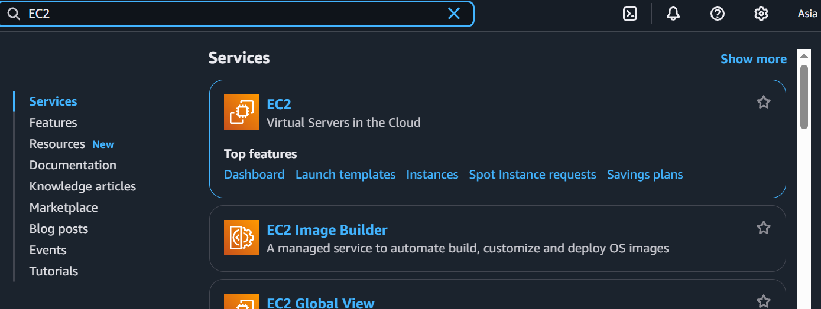



**Step 3: Launch an Instance**

1. Click on **Launch Instance**.(Add name)



1. Choose an Amazon Machine Image (AMI):
   * Pre-configured images with an OS and software.

1. Select an Instance Type:(create key to access this instance securely)
   * Choose based on CPU, memory, storage, and networking requirements.

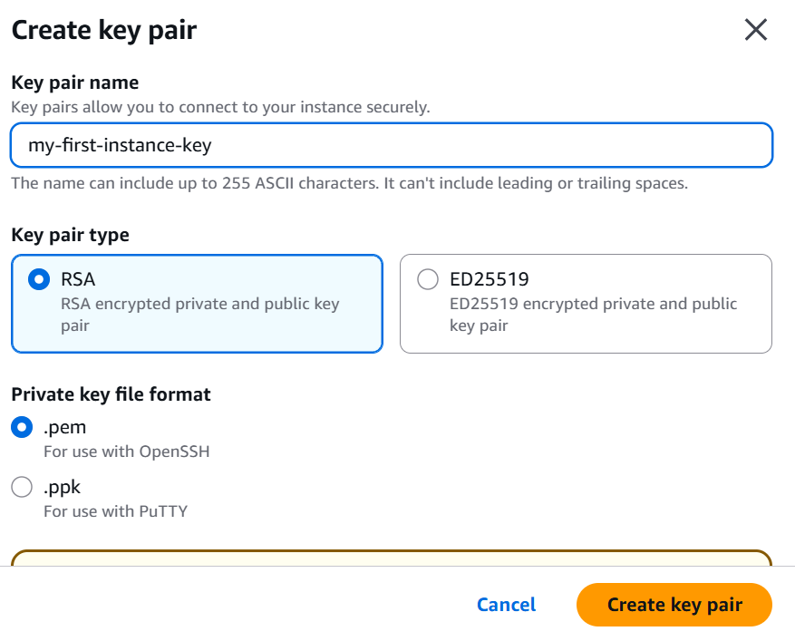



1. Configure Instance Details:
   * Specify VPC, subnet, Auto Scaling, and IAM roles.

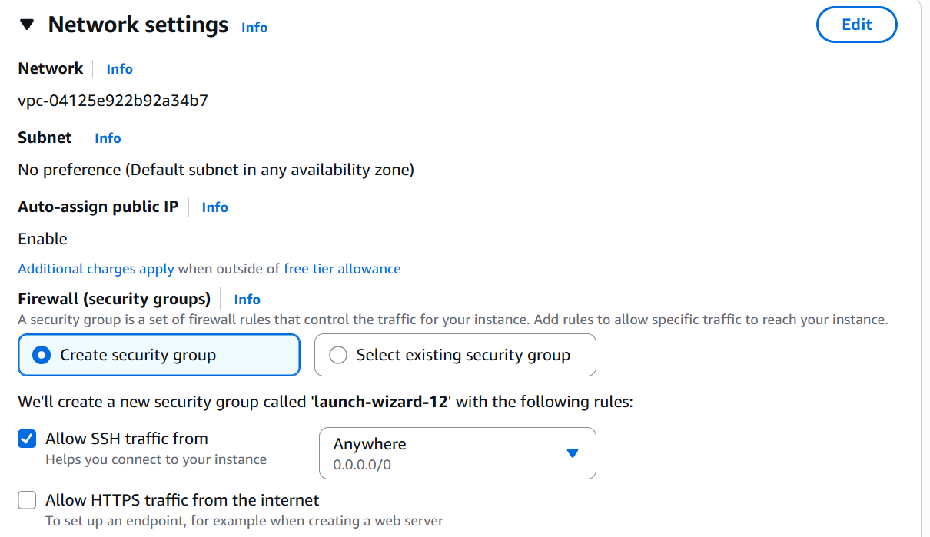

1. Add Storage:
   * Choose between Amazon EBS (Elastic Block Store) or instance store.

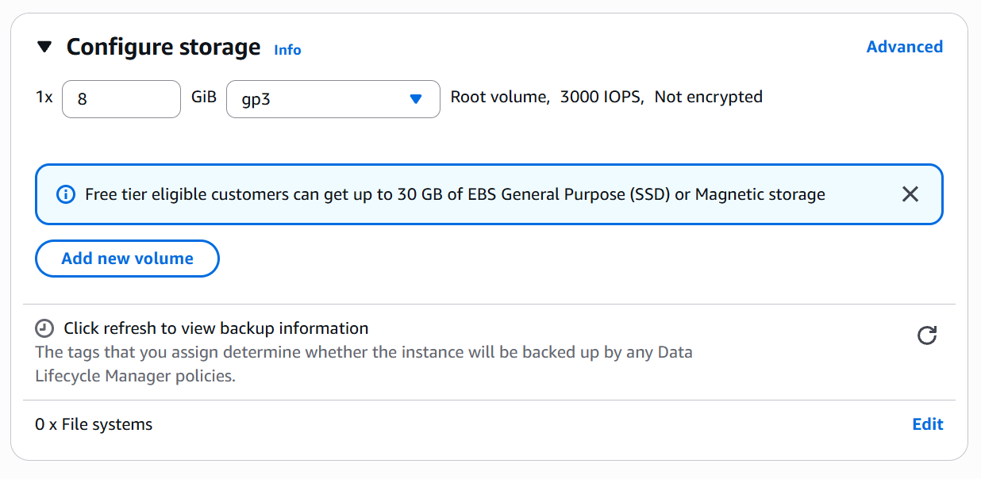



1. Configure Security Group:
   * Define inbound and outbound traffic rules.

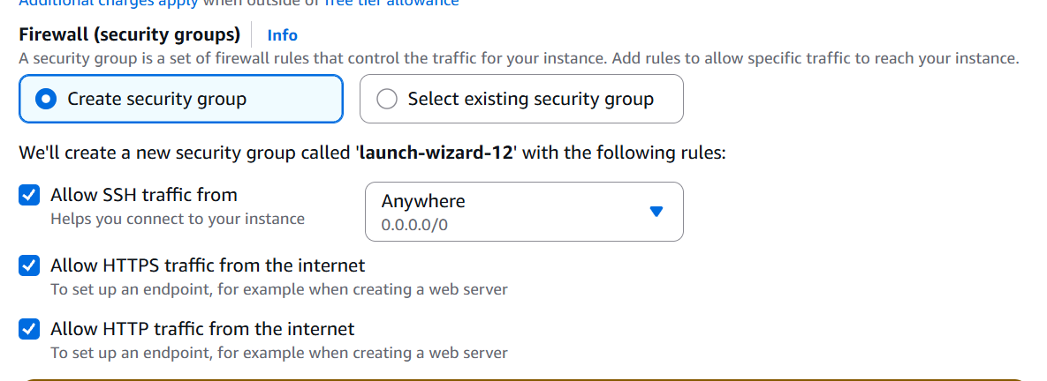

1. Review and Launch:
   * Select a key pair for SSH access and review your configurations.

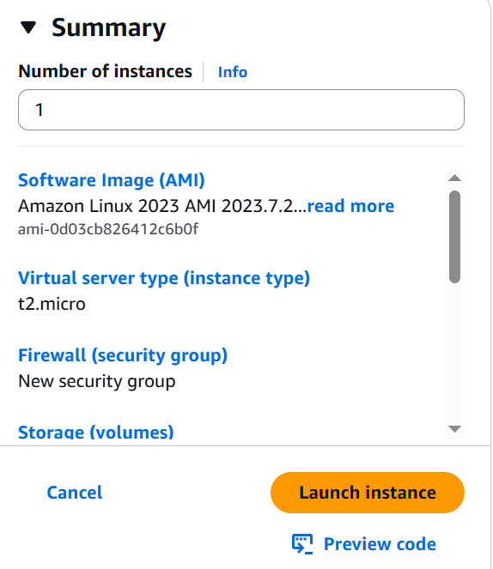

**Step 4: Connect to Your Instance**

* Use SSH (for Linux) or RDP (for Windows) to connect to your instance.
* Command example for SSH:

ssh -i "your-key.pem" ec2-user@your-instance-public-ip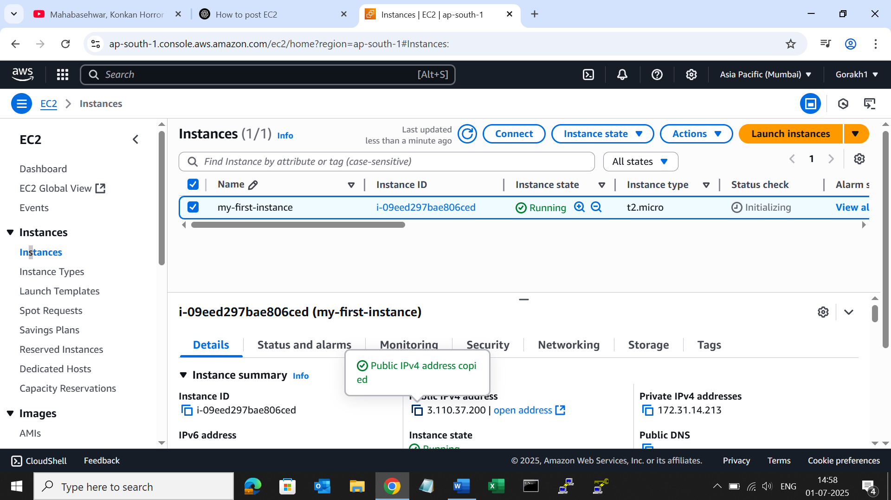

**Step 5: Monitor and Optimize**

* Use Amazon CloudWatch to monitor metrics like CPU utilization and disk I/O.
* Enable Elastic Load Balancing (ELB) for distributing traffic across instances.
* Set up Auto Scaling to manage scaling policies automatically.

**Best Practices**

**1. Cost Optimization**

* Leverage Spot Instances for non-critical workloads.
* Use Savings Plans for predictable workloads.

**2. Security Enhancements**

* Regularly update your instances and software.
* Apply the principle of least privilege with IAM roles.
* Enable Multi-Factor Authentication (MFA).

**3. High Availability**

* Deploy instances across multiple Availability Zones.
* Use Elastic Load Balancing to route traffic effectively.

**4. Backup and Recovery**

* Regularly create Amazon EBS snapshots.
* Use Amazon Machine Images (AMIs) for quick recovery.

**Common Use Cases**

**1. Web Hosting**

* Host websites or applications with scalable and reliable infrastructure.

**2. Big Data Analytics**

* Process and analyze large datasets using EC2 instances with high CPU and memory capacity.

**3. Gaming Servers**

* Host multiplayer gaming servers with low latency.

**4. Development and Testing**

* Create isolated environments for development and testing at scale.

**Key Features of EC2**

* **Elastic IP Addresses:** Static IPs that can be remapped to different instances.
* **Amazon EBS:** Persistent block storage for instances.
* **Instance Store:** Temporary storage for short-term needs.
* **Amazon CloudWatch:** Monitor and manage performance metrics.
* **Elastic Load Balancing:** Automatically distribute incoming traffic.

**Conclusion**

Amazon EC2 empowers businesses with flexible, scalable, and secure compute resources. Whether you’re deploying a simple application or managing a complex workload, EC2 provides the tools and infrastructure to meet your needs efficiently.